OSSP SKILL_2 PROGRAMS
PROGRAM-1 (CMD EXECUTOR):
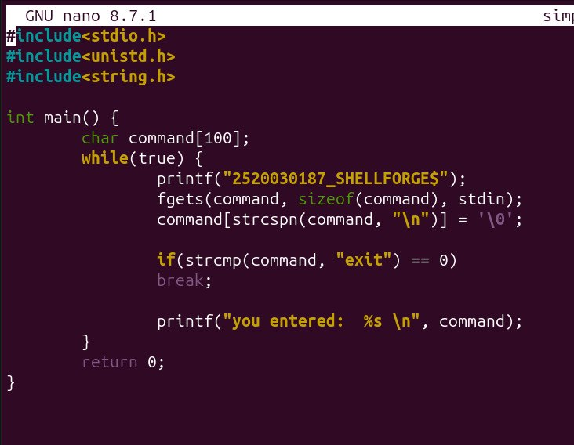

OUTPUT:
